EXCRETION

Excretion: the removal of waste products from respiration within cells.

The circulatory system ( specifically the blood) carries the waste products from respiration in the cells to the organs responsible for excretion - the lungs, skin, liver and kidneys.

If the waste products are not removed from the body, they would poison the body and end in death.

The waste products are CO₂, H₂O and urea.

The solid material passed out of the anus is not a waste product from
respiration - it is undigested food and fibre called faeces.

This process is called elimination or defaecation.

The liver removes fats and oils from the blood, changes them and send them to the body's fat deposits for storage. It removes excess protein from the blood and converts it into urea.

Urea is a toxic waste filtered from the blood by the kidneys. It is collected in the bladder and formed into urine (by adding H₂O) and then passed out of the body.

ORGAN | EXCRETORY PRODUCT
lungs | CO₂, H₂O
skin | H₂O
liver | fats, oils, protein
kidneys | H₂O, urea

Structure of the System

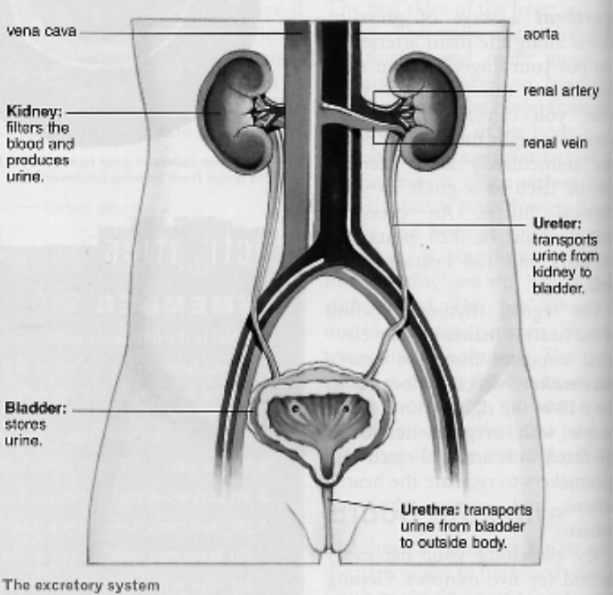

Structure of the Kidney

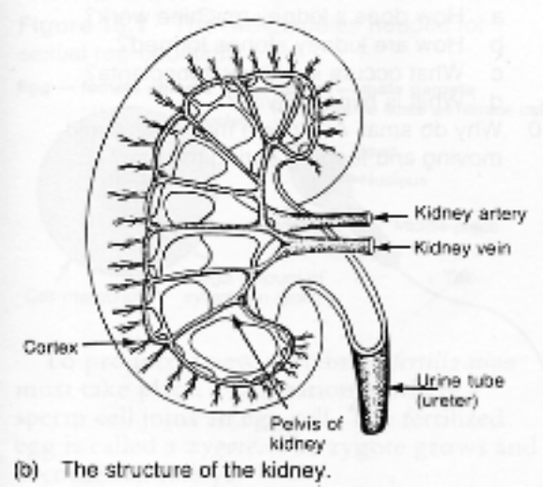

Cortex - filters the blood and collects the urea and water.

Pelvis - area where the urea and water collects to form urine.

Ureter - fine tubes that conduct the urine down to the bladder.

